Login to game

First step

First find the shortcut icon "Dawn of Light" game client on your desktop



Double-click to open and wait for the automatic update is complete.

The second step

After entering the login screen, click [Select Server] button to enter the selected server interface.



The third step

Double-click to enter the server, select the server is completed, the system will automatically return to the login screen.

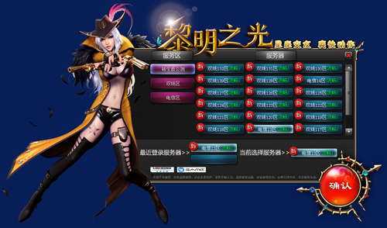

The fourth step

Click [Start Game] into the game, after a few seconds of cutscenes, according to the interface required to enter the Blue Harbor Pass account, password, confirmation and click [Login] button.

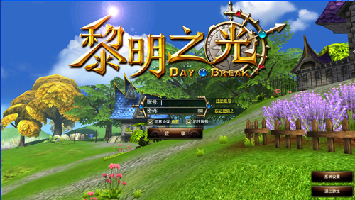

The fifth step

Click [Select existing roles into the game] to start the game, if you are a first time landing the game, you need to establish the role of point [] to create a new role.

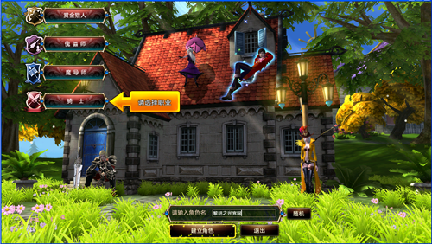

Step Six

Choose your favorite occupation, the role can further choose hairstyles, hair color and face. Enter the role nickname, click [role] to build into the game, start your adventure it!

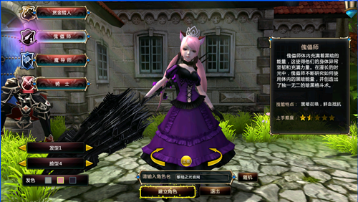

Special Note

In order to improve the safety of the player account information and account number and password protect the game login screen soft keyboard】 【increased functionality, players try to use the soft keyboard to enter the password.

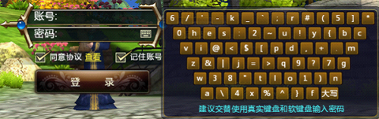

[Soft Keyboard]

Left-click on the graphic to open the soft keyboard soft keyboard interface, the soft keyboard input using the mouse to click the way the account and password, this can increase the degree of prevention Trojans. Soft keyboard keys randomly arranged, when the mouse on a button, the button will turn on, the case of the soft keyboard keys can help players to switch sensitive input. When the username and password entered, click again to close the soft keyboard soft keyboard graphic.